Here is a screenshot of my Lifecycle application during the 2nd Video:

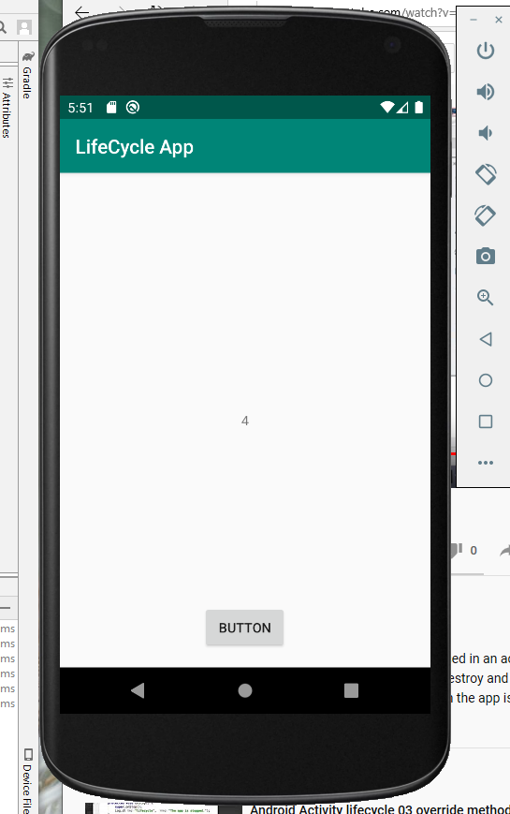

Screenshot of my lifecycle filter:

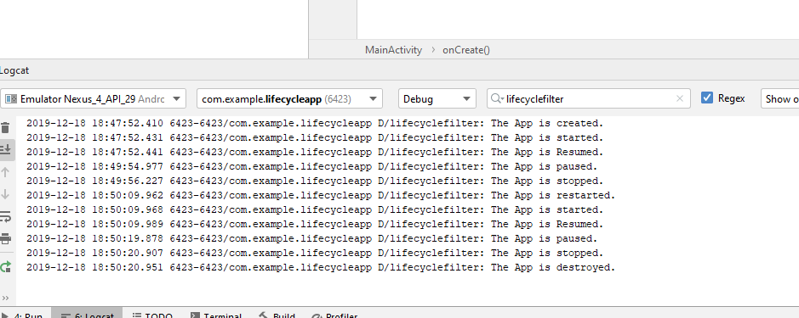

Here is a screenshot of my Lifecycle application final product:

